IRSE – YOUNGER MEMBERS
Module 5 Examination Workshop
Date: Saturday 20th August 2011 Venue: Network Rail Training Centre, Walsall

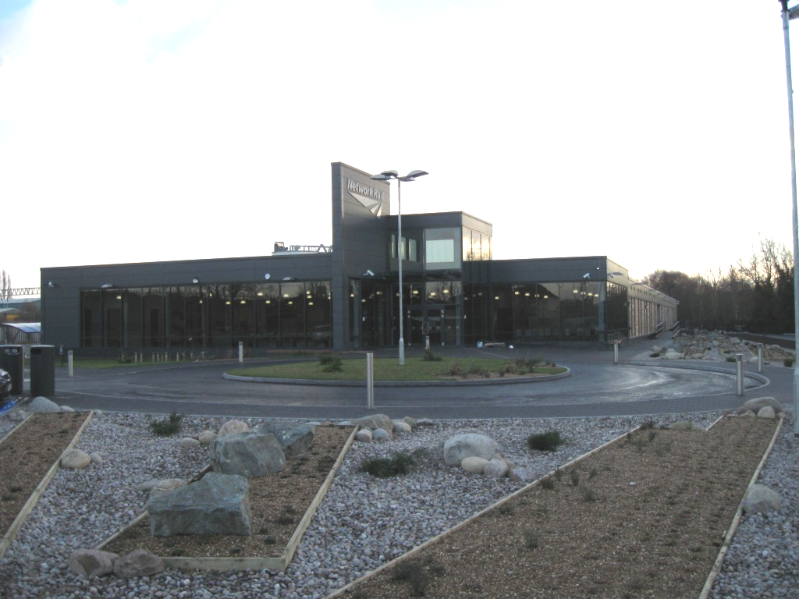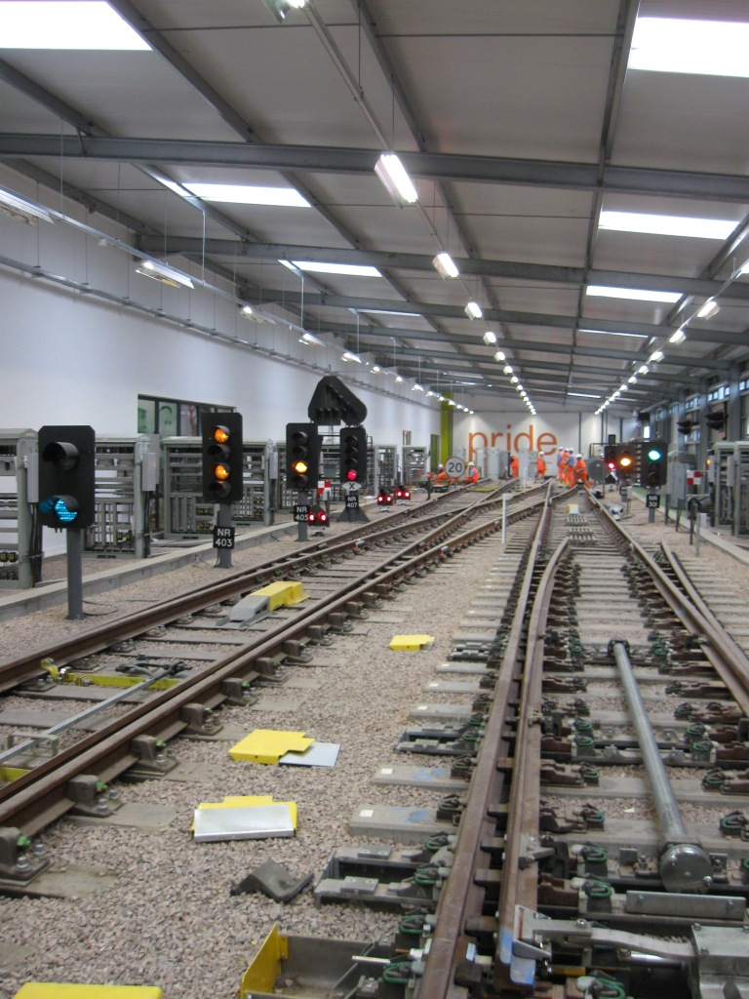

Exam workshops have proved a valuable resource for those studying for the IRSE professional exams. This year the IRSE Younger Members are pleased to announce that a Module 5 exam workshop will be held at Network Rail’s Training Centre in Walsall. The event presents an opportunity for Younger Members to get up close and personal with some of the most common signalling equipment installed in the UK, thus allowing delegates to explore the exam syllabus in a practical environment.

The aim of the workshop is to gain familiarity with a variety of signalling equipment and to look at a range of typical exam questions that have been attempted by candidates in advance. The day will focus on four key systems: Signals, Points, Train Detection and Level Crossings, but advice will also be given on good exam technique. Mock exam questions will be distributed to delegates. You may choose to undertake this as a timed mock exam or in more relaxed conditions according to your state of preparation and experience; we emphasise we are looking for a serious attempt which shows commitment, rather than necessarily attaining a particular quality standard. If you are at the learning stage, just use this opportunity to demonstrate what you know. The weekend will be tailored towards how these questions are attempted. This preparatory work is an essential part of the weekend – it is a rare opportunity to get feedback on how you are approaching questions under exam conditions and one that should not be missed.

This event is open to candidates intending on sitting the IRSE Module 5 exam in 2011 or future years, or any Younger Members interested in learning more about mainline signalling equipment.

You will be required to bring a Hard Hat, Hi-Vis Vest and Safety Boots. Should this pose a difficulty please advise when booking and we will try to arrange some for you. Thanks to our sponsors, Network Rail, the event is free to attend and a buffet lunch will be provided. Attendees will have to arrange their own travel and accommodation.

Timings for the day will be approximately 10am till 5pm, but will be confirmed along with the programme for the day. This event is free to attend and is open to both members and non-members of the IRSE, however priority will be given to those who submit an attempt at the mock exam questions.

To register your interest and obtain a copy of the mock exams please complete this form (or send the requested details) and send it by e-mail to: neil.thompson2@networkrail.co.uk

Saturday 20th August
Name: | IRSE Membership Number:
E-mail address:  Telephone:  Employer & Work Location:  Please note any specific dietary requirements below: | I am intending to sit module 5 in 2011  I require PPE (please state details below)

The Institution and the administrations whose sites will be visited during the workshop cannot accept any responsibility whatsoever for injury, damage or other difficulty which may arise during the workshop. Participants are therefore advised to ensure that their own insurance covers all appropriate eventualities.
A company limited by guarantee
Registered in England No. 125685
Registered Charity No. 1046999
Vat No. 863872191

