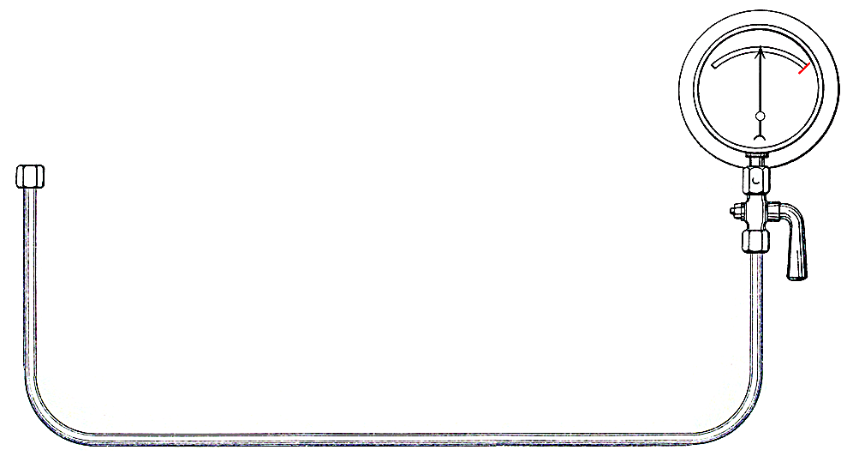

**NORTH EASTERN RAILWAY ENGINEER’S FORUM 2011**

*“ENGINEERING MODULAR SOLUTIONS”*

The evening of Tuesday 20th September 2011 will be the occasion of the sixteenth annual North Eastern Railway Engineer’s Forum to be held in the Walker Suite at the prestigious National Railway Museum in York. We promise a warm welcome to all engineers and interested parties who are able to attend.

The Forum was originally set up to get Railway Engineers of all disciplines to carry on talking to each other about problems and developments, in spite of the fragmentation of the industry following privatisation.

Each year we have been fortunate to get sponsorship to enable this event to take place. We are extremely pleased that the Railway Engineering firm Sabre Rail of Newton Aycliffe has generously agreed to underwrite the running costs of the 2011 Forum.

The Forum has always been a joint venture shared between the five Professional Railway Engineering organisations: IMechE, IET, ICE, IRSE & PWI. They address topics of mutual concern and interest in the running and development of the modern railway. In the past we have looked at topics such as: *The wheel/rail interface, Controlling Project Costs and Light Rail / Heavy Rail?* This year to reflect the need for the industry to improve the service to customers, reduce costs, and minimise disruptions, we have focussed on the use of modular engineering as our topic.

We have already lined up a group of four interesting and topical presentations which cover the whole spectrum of Railway Engineering: signalling, trackwork, electrification and trains themselves.

The running order for the evening will be as follows:

The audience will gather in the NRM at 6pm for tea and refreshments in the Great Hall before entering the Walker Suite. The first two papers will be followed by questions and a comfort break, before the second two papers and questions. The evening is expected to finish formally at 8.30pm. The speakers and sponsors will then be entertained to dinner as a thankyou.

During the day of the Forum we invite local schoolchildren to participate in fun activities which relate to the main evening topic, but explain to a new generation what Railway Engineers actually do and how they do it! They also get the chance to meet Young Engineers who come and help with the activities.

For further information on the content of the Forum or other queries please contact Richard Gibbon on 01904 631840 or by email on rhgibbon@gmail.com